Data communication

Functionality of Computer Network:
Mandatory function:
- Error control:By using the error control process, we can be confident that the transmitted and received data are identical. Data can be corrupted during transmission. The error must be detected and corrected for reliable communication.
- Access control:Network access control is the act of keeping unauthorized users and devices out of a private network.
- Flow control:Flow control is a technique that allows two stations working at different speeds to communicate with each other.
- Multiplexing and demultiplexing:Multiplexing is a process that allows multiple signals to travel simultaneously over a single communication channel or path. And combining multiple unrelated analog or digital signal streams into one signal over a single shared medium.
- Adressing:A network address is any logical or physical address that uniquely distinguishes a network node or device over a computer or telecommunications network.

Optional function:
- Routing:A Router is a process of selecting path along which the data can be transferred from source to the destination. Routing is performed by a special device known as a router.
- Checkpointing:checkpoint is a copy of the computer's memory that is periodically saved on disk along with the current register settings. In the event of a failure, the last checkpoint serves as a recovery point.
- Encryption and Decryption:Encryption means that the sender converts the original information into another form and sends the unintelligible message over the network.Decryption reverses the Encryption process in order to transform the message back to the original form.

Divide And Conquer:
This technique can be divided into the following three parts:
1. Divide:This involves dividing the problem into smaller sub-problems.
2. Conquer:Solve sub-problems by calling recursively until solved.
3. Combine:Combine the sub-problems to get the final solution of the whole problem.
- Abstraction :It is the process of filtering out – ignoring - the characteristics of patterns that we don't need in order to concentrate on those that we do.
- Encapsulation : It is the process of adding additional information when data is traveling in OSI or TCP/IP model. The additional information has been added on sender’s side, starting from Application layer to Physical layer.
- Testing:
Physical layer:
Physical layer in the OSI model plays the role of interacting with actual hardware and signaling mechanism.
- Electrical:Copper wire to wireless.
- Mechanical:optical to light
- Procedural:wireless to EMV
- Functional:Modes of transmission
  - Topology
  - Encoding

Modes of Transmission Medium :
- Simplex mode:In this mode, out of two devices, only one device can transmit the data, the other device can only receive the data. Example- Input from keyboards.
- Half Duplex mode:In this mode, out of two devices, both devices can send and receive the data but only one at a time not simultaneously. Example- Walkie-Talkie.
- Full-Duplex mode:In this mode, both devices can send and receive the data simultaneously. Example- Telephone System.

TOPOLOGY:
- Mesh Topology:In a mesh topology, each and every device should have a dedicated point-to-point connection with each and every other device in the network.
  - Adv:
    - Data transmission is more consistent because failure doesn’t disrupt its processes
    - Adding new devices won’t disrupt data transmissions.
  - DisAdv:
    - Installation is extremely difficult in the mesh.
    - Complex process.

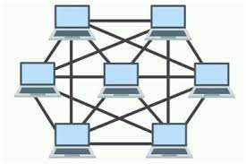

- Star Topology:In star topology, the device should have a dedicated point-to-point connection with a central controller or hub.
  - Adv:
    - no point to point connection
    - easy to maintain
  - DisAdv:
    - More expensive than linear bus topology due to the value of the connecting devices
    - If hub goes down everything goes down, none of the devices can work without hub.

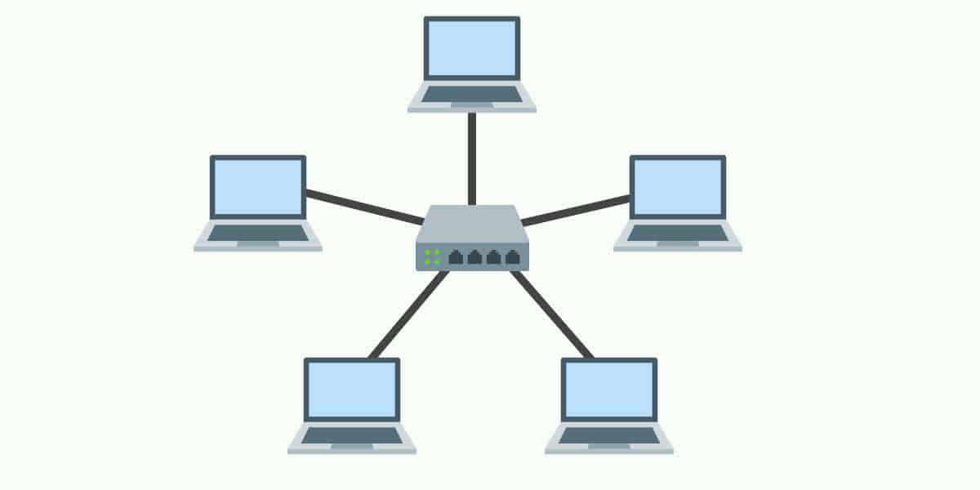

- Bus Topology:In a bus topology, multiple devices are connected through a single cable that is known as backbone cable.
  - Adv:
    - simple to understrand and set-up
    - Very cost-effective as compared to other network topology
  - DisAdv:
    - If a main cable is damaged, whole network fails or splits into two.
    - This network topology is very slow as compared to other topologies because of acess time for last devices.

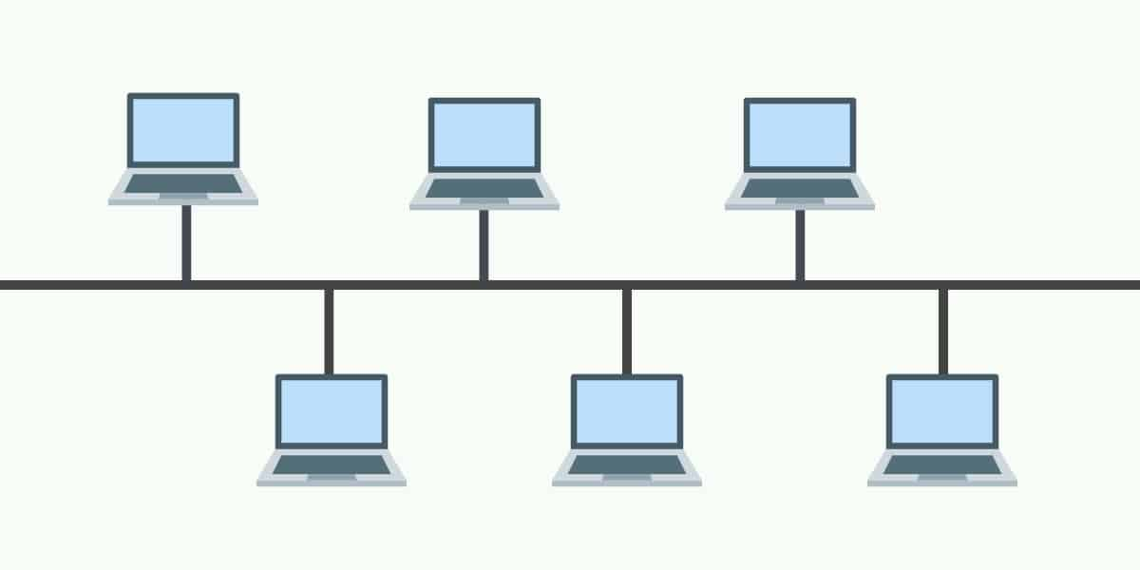

- Ring Topology:In a ring topology, each device is connected with repeaters in a circle-like ring that’s why it is called Ring Topology.an sen
  - Adv:
    - Speed to transfer the data is very high in this type of topology.
    - All data flows in one direction, reducing the chance of packet collisions.

  - DisAdv:
    - It is difficult to maintain.
    - It will be difficult to add other device when one goes down.
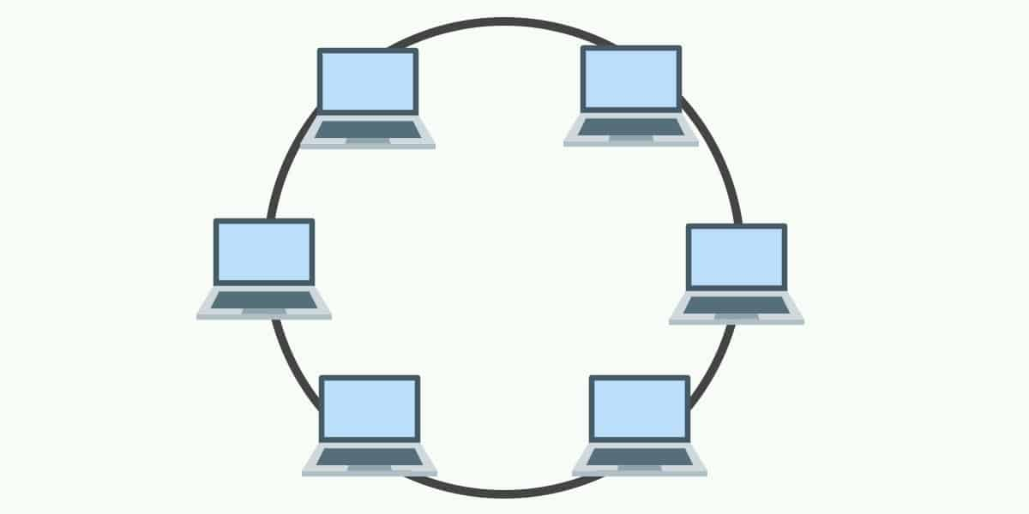
d the data only when it has a token, without a token no device can send the data, and a token is placed by

- Hybrid topology:It is the combination of two or more different topologies.
  - Adv:
    - It is extremely flexible.
    - Handles large volume of traffic.

  - DisAdv:
    - Design of a hybrid network is very complex.
    - Installation is a difficult process.

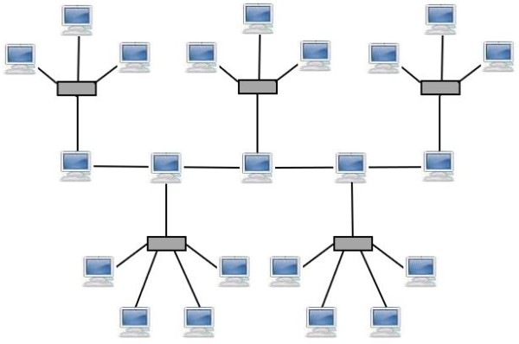
ing Topology.

Data link layer :
Data link layer hides the details of underlying hardware and represents itself to upper layer as the medium to communicate.Data link layer works between two hosts which are directly connected in some sense. This direct connection could be point to point or broadcast.

Data link layer has two sub-layers:
• Logical Link Control: It deals with protocols, flow-control, and error control
• Media Access Control: It deals with actual control of media

Functionality of Data-link Layer
Framing:Data-link layer takes packets from Network Layer and encapsulates them into Frames.Then, it sends each frame bit-by-bit on the hardware. At receiver’ end, data link layer picks up signals from hardware and assembles them into frames.
Addressing:Data-link layer provides layer-2 hardware addressing mechanism. Hardware address is assumed to be unique on the link. It is encoded into hardware at the time of manufacturing.
Synchronization:When data frames are sent on the link, both machines must be synchronized in order to transfer to take place.
Error Control:Sometimes signals may have encountered problem in transition and the bits are flipped.These errors are detected and attempted to recover actual data bits. It also provides error reporting mechanism to the sender.
Flow Control:Stations on same link may have different speed or capacity. Data-link layer ensures flow control that enables both machine to exchange data on same speed.

